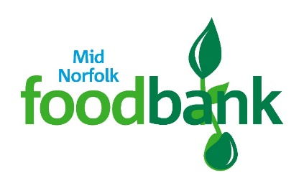
Easter Opening Times
Dereham Foodbank will be closed on Good Friday April 7th but open between 1.30pm and 3.30pm on Bank Holiday Monday April 10th.
Fakenham and Swaffham Foodbanks will both be closed on Bank Holiday Monday April 10th.

